

SAPPHIRE KHANACROSS 27 SEPTEMBER RESULTS
Thank you to all entrants in our fourth Khanacross event for 2026 for making it such an enjoyable day, especially our many new entrants in the Ladies Class. We apologise for the restricted track access. Sapphire Speedway needed to re-gravel sections of the course.
Thank you also for the positive feedback on the event format and on the course layout designed by Clerk of Course Ty Hooper, which suited many different classes of vehicle. It was great to see husbands and wives, and sons and daughters, joining in the fun.
A special mention goes to Nathan Softly and others who lent their cars to Jussi Burn after his own car was put out of action. That is the true spirit of our Khanacross events.
Once again, the scoreboard made by Danny Kaye of Design Post Bega was where competitors gathered to check scores and trade the usual banter. The scores and class winners are shown below in front of the scoreboard. It also displays our 2026 sponsors, whose support helps keep this form of motorsport affordable for everyone taking part.

Results
The junior entrants stood out again. All of them cut their run times significantly over the day, and at this rate they will soon be among the top times.
Unfortunately, a scoring error meant the award for fastest junior driver was not presented on the day. It rightfully belongs to Brandon Beverage. His points tally has been corrected, and his trophy will be presented in due course.
Reagen Hurley set the fastest time of the day, which looks like a bid for full rally competition. We can't wait to see it happen! Mark Wiley was close behind in second place. His consistency puts him in the running to lead the series on points.
First-time entrants Joel Wilson (our newly elected Club Secretary) and Juho Maliniemi, sharing a Datsun 180B, will be a challenge for all contenders in the future.
Other class winners:
- Class A: Ty Hooper, in the Mighty Mirage
- Class B: Geoff Dunstan, in the silent Astra
- Class D: Matt McDonald, in the Statesman limo
- Ladies Class: Nakayla Rootsey
Matt McDonald, in the Holden Statesman, won back the award for most entertaining driver of the day. Callum Thompson was close behind in his Falcon. We are thinking about a special award for whichever of them can stay sideways for the entire course!
We were all relieved to see Jaime Hayden finish an event without rolling a tyre off its rim. Funny how the times improve when you're not driving on a bare rim: second in class and fifth outright.

Thanks to Our Officials
Special thanks again to:
- Mal Irvin, for preparing the track and running the water truck
- Matt McDonald, for scrutineering
- Robbo, for the much-appreciated Class Award trophy glasses
- The Patton family (Kev, Cecilia and Clifford), who staffed the remote fire safety point for the whole event and took the excellent action photos in this report. Strangely, their spot matched up with a rare sighting of THE STICK!

Important: Officials Needed
The club needs members to volunteer as backup officials for future events. We have come close to cancelling events on the day because we might not have had enough first aid officers and other officials. That includes the Clerk of Course (track layout), scorers and starting marshals. With more accredited officials, we can share the jobs across the day so people can take a break, and even have a run of their own!
AASA officials' licences are free and easy to get. They give you the accreditation to officiate at anything from Khanacross to major motorsport track events. Please phone me on 0488 940 152 and I'll help you get your licence.

Survey: The Future of Khanacross
We will soon send out a survey asking what you'd like from future Khanacross events. Entries are now limited by the number of events Sapphire Speedway allows, which is five a year. To give everyone five runs per event, the field is capped at 35 entries, and more than 35 entrants now want a start.
The options range from five two-day events at the speedway to more events at another venue without these limits, including driver training and practice days.
Thanks again to all participants, and especially to the hard-working officials on the day.
Mark Hankinson
2026 Khanacross Series Coordinator

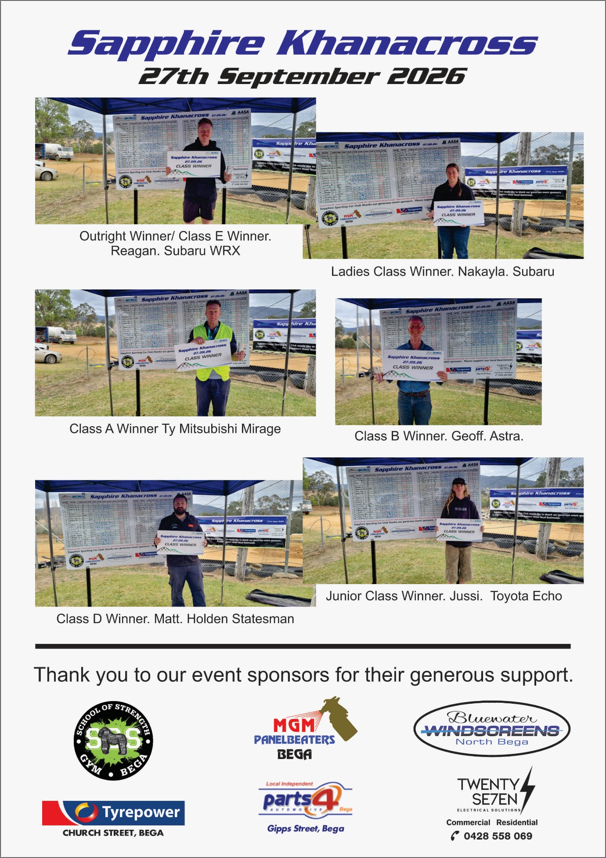

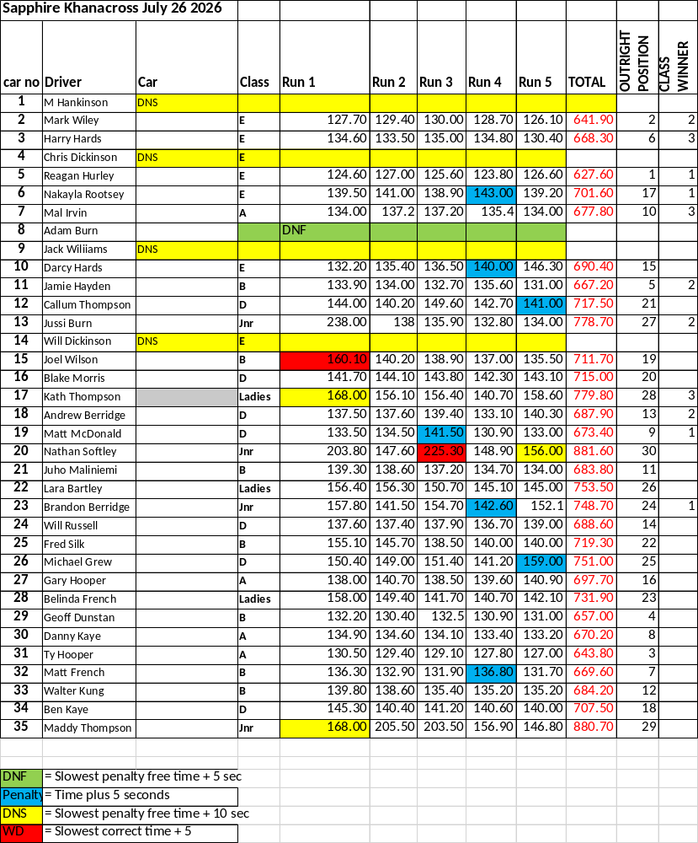

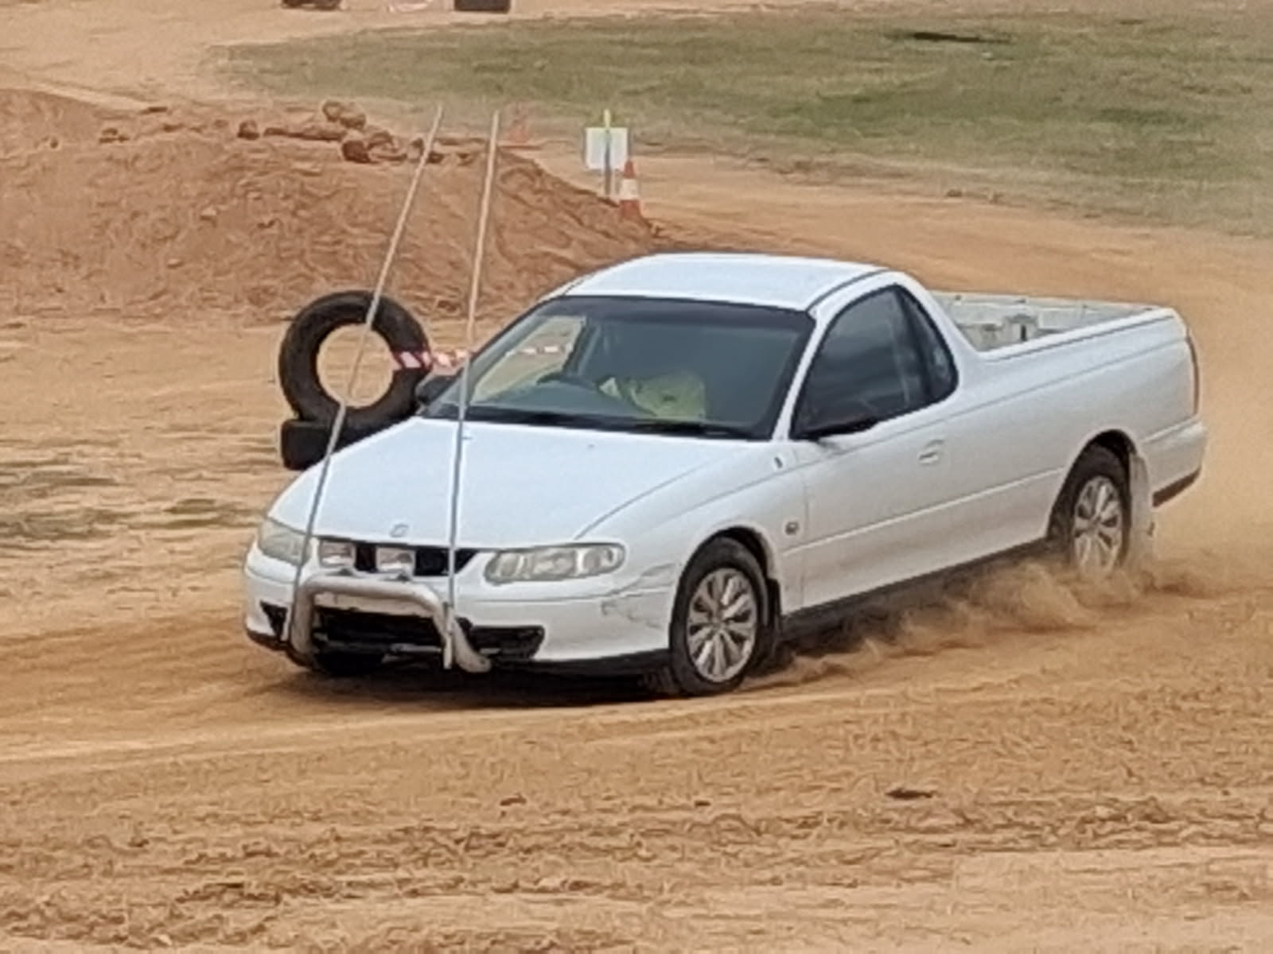
Blake

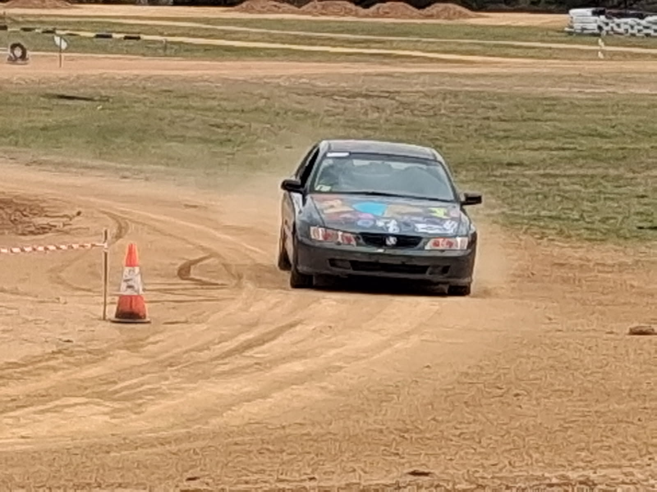
Berridge Family

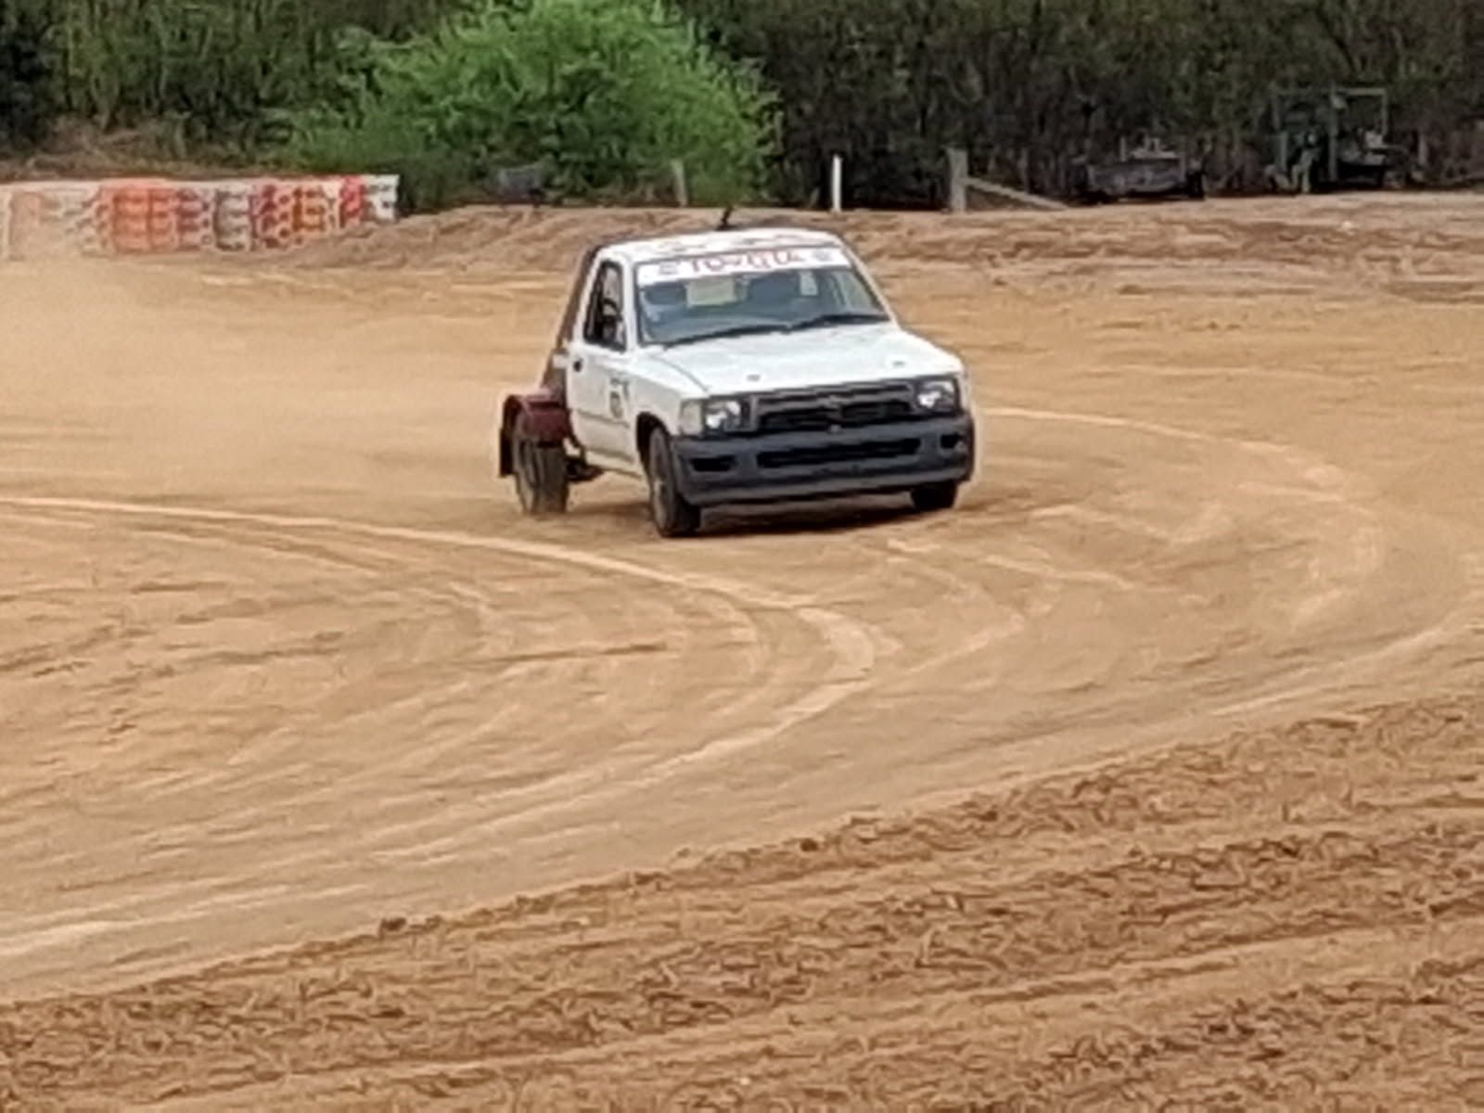
Ben Kaye

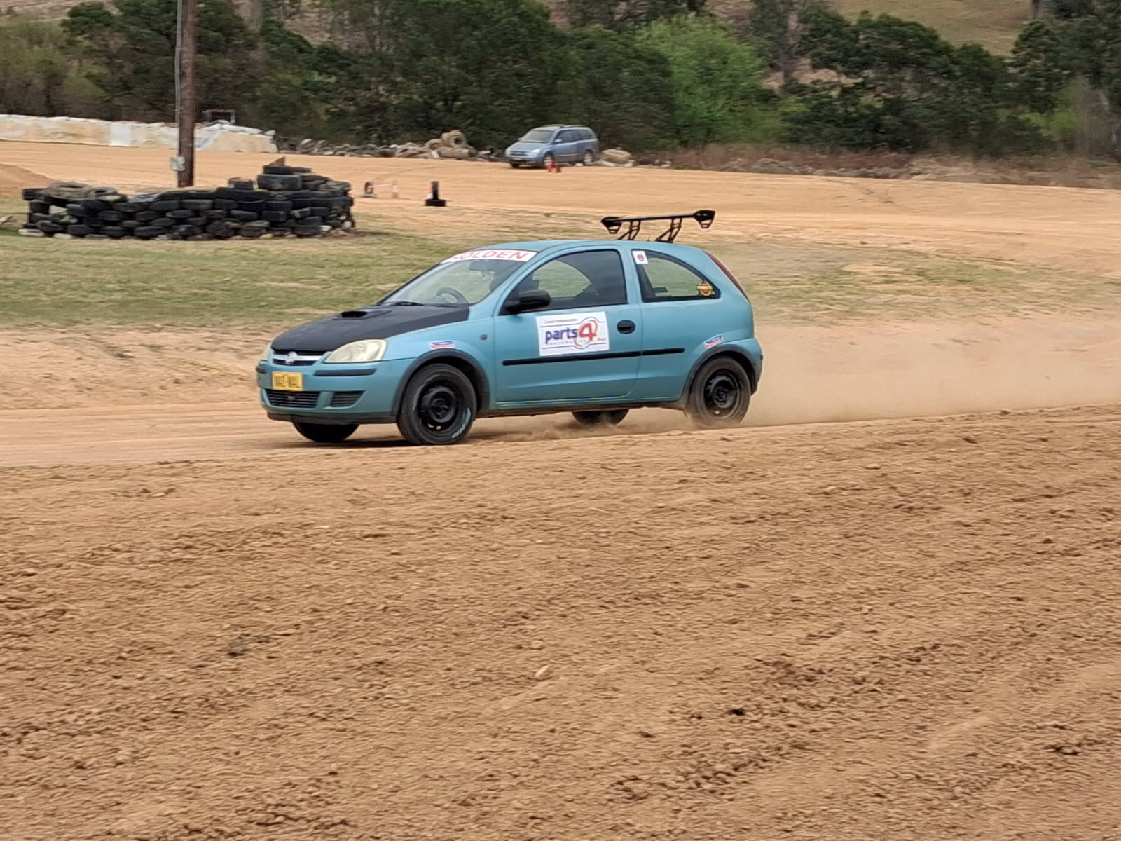
Mad Mal

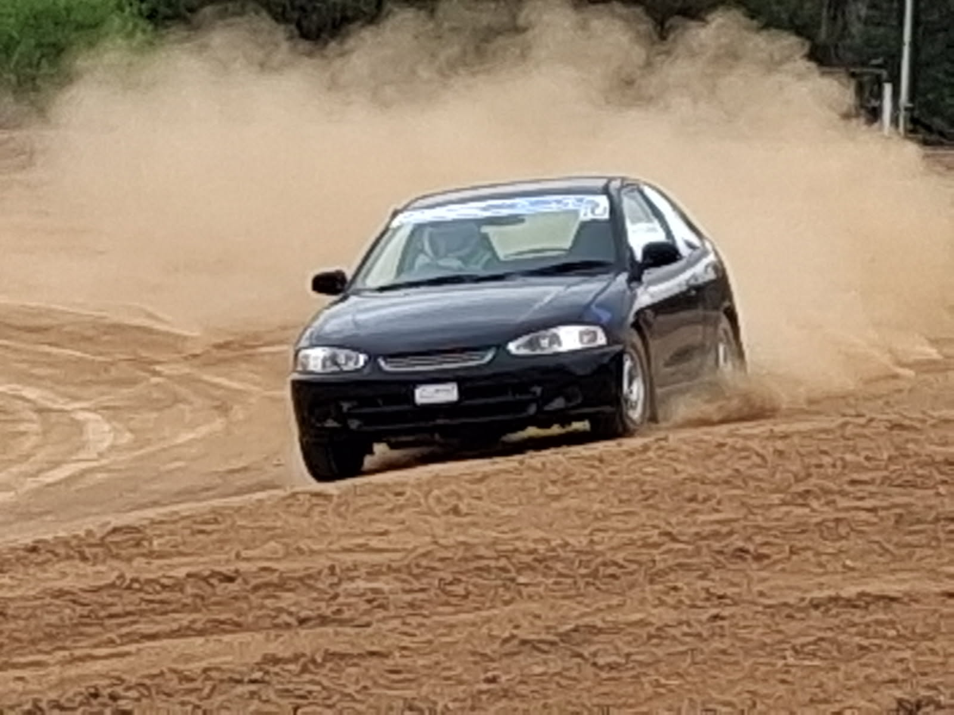
Ty Hooper

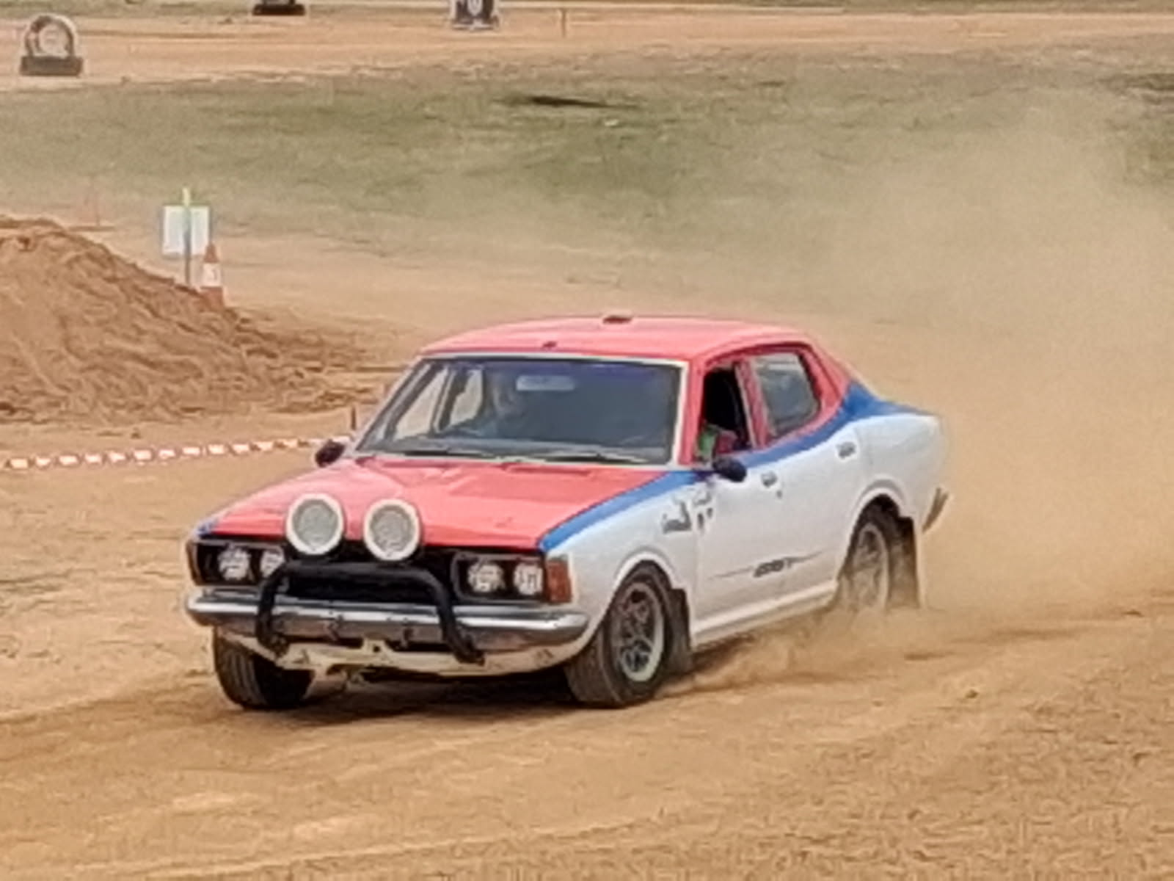
Joel and Juho

