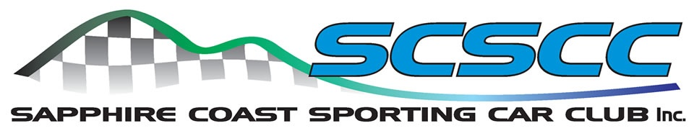
SAPPHIRE KHANACROSS 26 JULY RESULTS
Thanks to all entrants in this third Khanacross event for 2026 for making this a most enjoyable day for all involved. Sincere thanks for the positive feedback regarding the event format and the course layout, which catered for many different classes of vehicles, from family cars to full on rally cars.
The scoreboard created by Danny Kaye of Design Post Bega was a central point for competitors to gather and check scores, as well as indulge in the usual banter. Class winners are shown below in front of this great new feature of the series.
This scoreboard also highlights sponsors for this event. Their contribution is most welcome to keep this form of motorsport affordable for all competitors.
Again, a standout feature of the results was the performance of the junior entrants, who all improved their course run times significantly throughout the day. At this rate of improvement, they will be right amongst the top times in future results.
Fastest time of the day went to Chris Dickinson, sadly copping penalties for wrong directions on 2 other runs. Brother Will Dickinson took out the overall 1st outright position with very quick and consistent times, closely followed by Mark Wiley in second place.
Other class winners were Ty Hooper in the Mighty Mirage, Geoff Dunstan in the silent Astra, Mark Hankinson in the 200B, Matt McDonald in the Statesman and Will Dickinson in the Subaru Impreza. Lady’s honours went to Nakayla Rootsey, while yet again Jussie Burn took out the Junior Class in the Daihastu Charade, with times improving on each run. Most improved throughout the day went to Nathan Softley, ably assisted by Gary Targett in the Toyota Echo, with the Washbrook brothers competing strongly with each other.
The new clear winner of the award for most entertaining driver of the day was Callum Thompson in his Falcon, who would have been much quicker if the car pointed in the right direction for more than 2 seconds!
Special thanks must go to Mal Irvin for track preparation and manning the water truck, Matt McDonald for scrutineering duties and Robbo for his well-received Class award Trophy glasses. The club also welcomes members to volunteer as officials for future events. AASA officials’ licences are free of charge. More info to follow.
Thanks again to all participants, especially all of the hard-working officials on the day.
Mark Hankinson, 2026 Khanacross Series Co-ordinator.

